

**UNIVERSITI TEKNOLOGI MALAYSIA**

### SEMESTER 2 2021/2022

**ALTERNATIVE ASSESSMENT**

**INTEGRITY DECLARATION FORM**

Name of the Subject: **Special Topic on Bioinformatics**

Code of the Subject: **SCSB4243**

Title of the Project/Portfolio/Case Study/Others (Please State): **Alternative Assessment - Classification of Obesity Level Using Machine Learning**

Read, complete and sign this statement and enclose with your submitted work

1. I confirm that this submitted work is all my own work and is in my own words.
2. The sources (books,journals, website etc) I referred to and from which I have quoted or from which I got a substantial amount of information directly relevant to this work (if any) are fully listed in the references and/or acknowledgements sections of the Project/Portfolio/Case Study.
3. I understand that by the University code and any suspect activity of this nature (cheating, copying etc) will be reported to the Associate Chair (Academic and Student Development) and may be considered a breach of integrity, fraudulent behavior and violation of these principles will lead to a ZERO MARK on this assessment.

**STUDENT RESPONSIBILITY:**

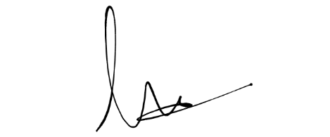I pledge to uphold my integrity that I have neither nor received any unauthorized assistance on this exam and that this work is my own.

___________________________

(Student’s signature)

**Student Name : Ji Tong Lin**

**Section : 01**

**Date : 3 July 2022**

**Time : 10:40pm**